The Blind Men and the Elephant
John Godfrey Saxe (1816-1887)
It was six men of Indostan  To learning much inclined,  Who went to see the Elephant  (Though all of them were blind),  That each by observation  Might satisfy his mind. | The Fourth reached out an eager hand,  And felt about the knee  "What most this wondrous beast is like  Is mighty plain," quoth he:  "'Tis clear enough the Elephant  Is very like a TREE!"
The First approached the Elephant,  And happening to fall  Against his broad and sturdy side,  At once began to bawl:  "God bless me! but the Elephant  Is very like a WALL!" | The Fifth, who chanced to touch the ear,  Said: "E'en the blindest man  Can tell what this resembles most;  Deny the fact who can,  This marvel of an Elephant  Is very like a FAN!"
The Second, feeling of the tusk,  Cried, "Ho, what have we here,  So very round and smooth and sharp?  To me 'tis mighty clear  This wonder of an Elephant  Is very like a SPEAR!" | The Sixth no sooner had begun  About the beast to grope,  Than seizing on the swinging tail  That fell within his scope,  "I see," quoth he, "the Elephant  Is very like a ROPE!"
The Third approached the animal,  And happening to take  The squirming trunk within his hands,  Thus boldly up and spake:  "I see," quoth he, "the Elephant  Is very like a SNAKE! | And so these men of Indostan  Disputed loud and long,  Each in his own opinion  Exceeding stiff and strong,  Though each was partly in the right,  And all were in the wrong!

The moral of the story is that there may be some truth to what someone says. Sometimes we can see that truth and sometimes not because we may have different perspectives. So, rather than arguing like the blind men, we should say, "Maybe you have your reasons."

ELEPHANT AND THE BLIND MEN
Once upon a time, there lived six blind men in a village. One day the villagers told them, "Hey, there is an elephant in the village today."
They had no idea what an elephant is. They decided, "Even though we would not be able to see it, let us go and feel it anyway." All of them went where the elephant was. Everyone of them touched the elephant.
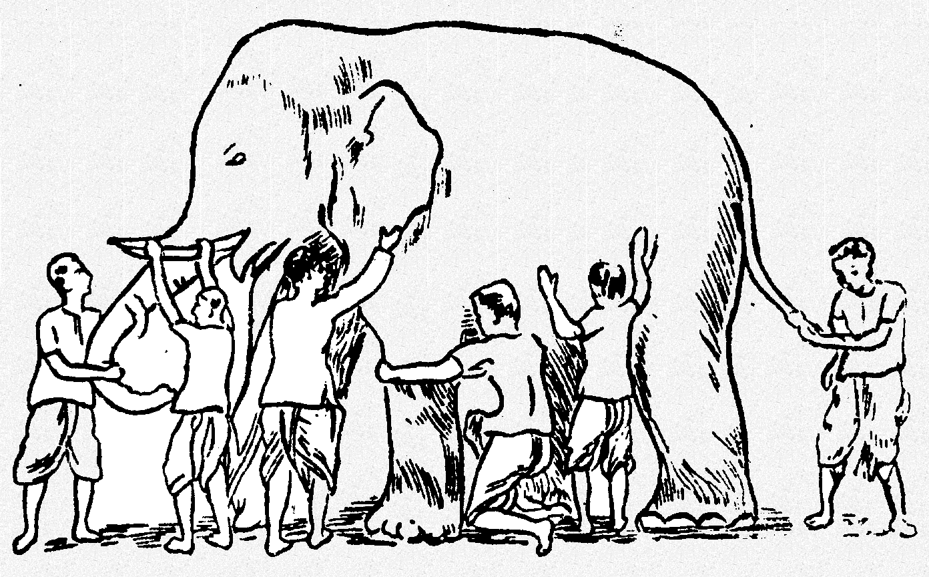

"Hey, the elephant is a pillar," said the first man who touched his leg.
"Oh, no! it is like a rope," said the second man who touched the tail.
"Oh, no! it is like a thick branch of a tree," said the third man who touched the trunk of the elephant.
"It is like a big hand fan" said the fourth man who touched the ear of the elephant.
"It is like a huge wall," said the fifth man who touched the belly of the elephant.
"It is like a solid pipe," Said the sixth man who touched the tusk of the elephant.
They began to argue about the elephant and everyone of them insisted that he was right. It looked like they were getting agitated. A wise man was passing by and he saw this. He stopped and asked them, "What is the matter?" They said, "We cannot agree to what the elephant is like." Each one of them told what he thought the elephant was like. The wise man calmly explained to them, "All of you are right. The reason every one of you is telling it differently because each one of you touched the different part of the elephant. So, actually the elephant has all those features what you all said."
"Oh!" everyone said. There was no more fight. They felt happy that they were all right.
The moral of the story is that there may be some truth to what someone says. Sometimes we can see that truth and sometimes not because they may have different perspective which we may not agree too. So, rather than arguing like the blind men, we should say, "Maybe you have your reasons." This way we don’t get in arguments. In Jainism, it is explained that truth can be stated in seven different ways. So, you can see how broad our religion is. It teaches us to be tolerant towards others for their viewpoints. This allows us to live in harmony with the people of different thinking. This is known as the Syadvada, Anekantvad, or the theory of Manifold Predictions.

