Talk ** Write ** Learn

Design Your Own - Intermediate

Use these blank forms to design your own Talk ** Write ** Learn lesson. Use your state’s content standards (probably the CCSS), and your version of the ELP standards.

Objectives

 | Standards (copy here) | Objectives
Content: CCSS/NGSS

________
 |  | by
Language:

ELPS

________
 |  | and
Language:

Writing

________

The Frames

Decide which frames you will need to match the standards and objectives. You can download a list for Level 1 or Level 2-3 ELL students at www.langdevopps.com/resource under Academic Conversations.

Input media: What will students read, see, do, hear to give them material for conversation?

The Chunks (edit and print for students) (repeat as necessary)

Decide on the kind of input the students will receive, whether reading, reading to them, video or other. Decide on the size of the chunks and the guiding questions for each discussion period. Copy this form as many times as necessary.

Write question here | Write the appropriate frame here from your list above
Write your response and what you might have learned from your partner:

Write question here | Write the appropriate frame here from your list above
Write your response and what you might have learned from your partner:

Write question here | Write the appropriate frame here from your list above
Write your response and what you might have learned from your partner:

Write question here | Write the appropriate frame here from your list above
Write your response and what you might have learned from your partner:

Write question here | Write the appropriate frame here from your list above
Write your response and what you might have learned from your partner:

Write question here | Write the appropriate frame here from your list above
Write your response and what you might have learned from your partner:

Copy more as needed
Conversation Assessment (for student use)
Revise the Conversation Counter to match the conversation skills and frames you are using. Print and give to the scorekeeper.
In groups of four: One and two talk; three checks one, four checks two. Change roles periodically.

In groups of three: one and two talk, three checks one. Switch: two and three talk, one checks two. Switch: three and one talk, two checks three.

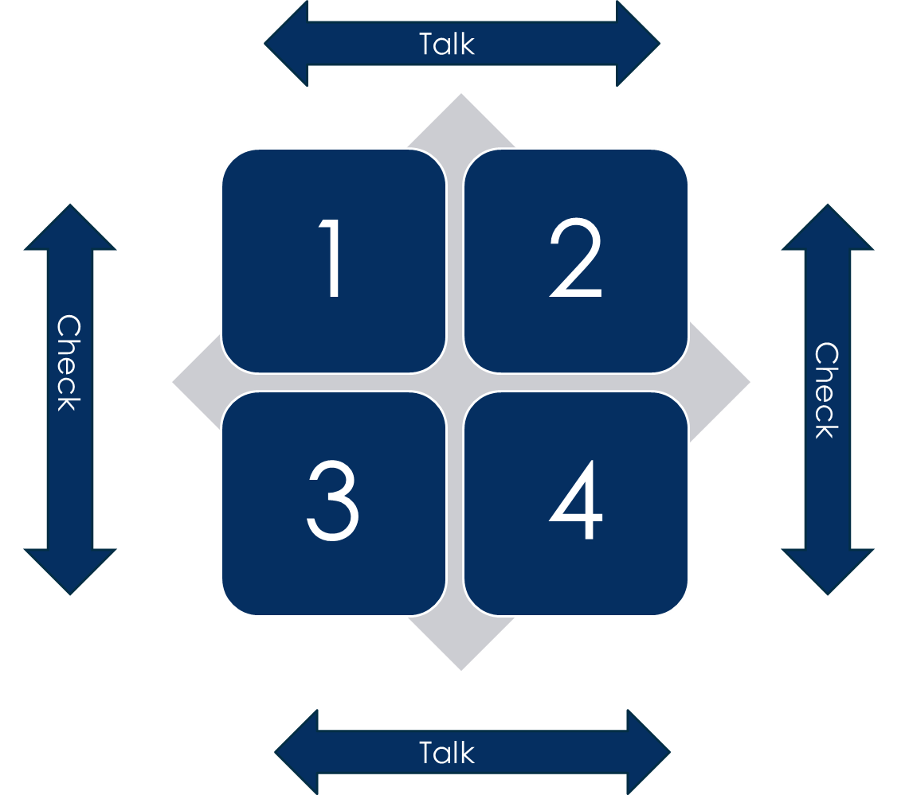
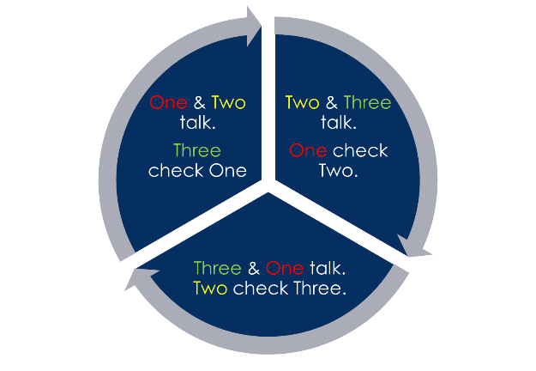

Conversation Counter

My Name _______________________

I’m checking _____________________

Date____________________________________
Place a tally mark next to each talk move my partner completes.

For students, use writing paper or electronic version. Apply CCSS writing standards for your grade level.

Bubble Map

Name__________________________________________________ Date_________________
Opinion:
___________________________________________________________________________

___________________________________________________________________________

___________________________________________________________________________
Reason 1: | Reason 2: | Reason 3:
Evidence 1: | Evidence 1: | Evidence 1:
Evidence 2: | Evidence 2: | Evidence 2:
Opinion (restated):
___________________________________________________________________________

___________________________________________________________________________

___________________________________________________________________________

Final Draft
Revise and replace words and phrases to make your meaning more clear. Check that you have an effective introduction and conclusion.

Presentation (optional)

Stand and present your findings or conclusions orally. (You might want to design a separate rubric for oral presentation.)

